**Can you Make yourself a new Scouts Woggle**

**Supplies** cord orrope of **100 cm** length.

**Step 1: History of Woggle**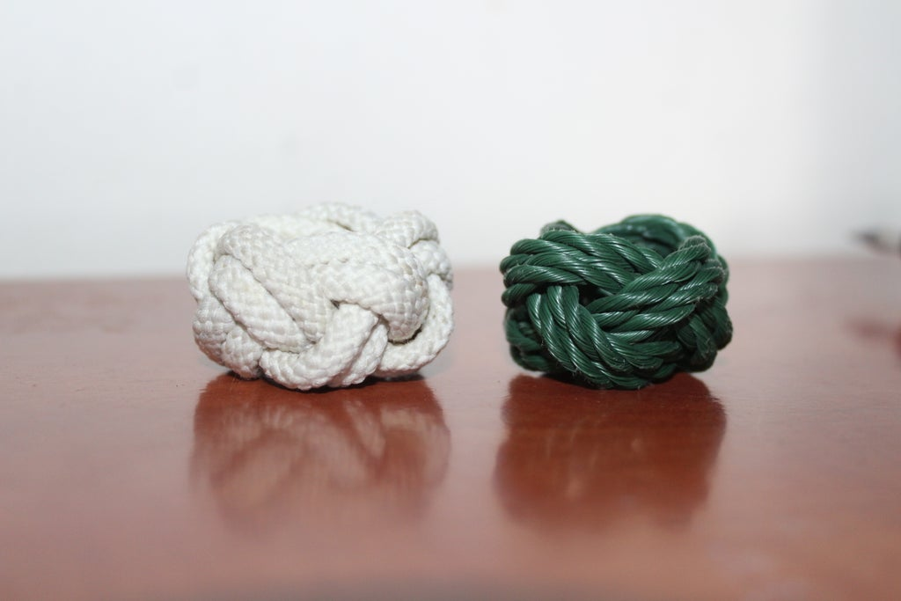The earliest known reference to a woggle is the June 1923 edition of The Scout. The term was quickly applied to other designs of the fastener, of many shapes and sizes, and is today used around the world.

The word ring was used in editions of the Scouting handbook Scouting for Boys until 1929 when Baden-Powell changed it in the 14th edition: It may be fastened at the throat by a knot or woggle, which is some form of ring made of cord, metal or bone, or anything you like.

## **Step 2: Make an X-shape**

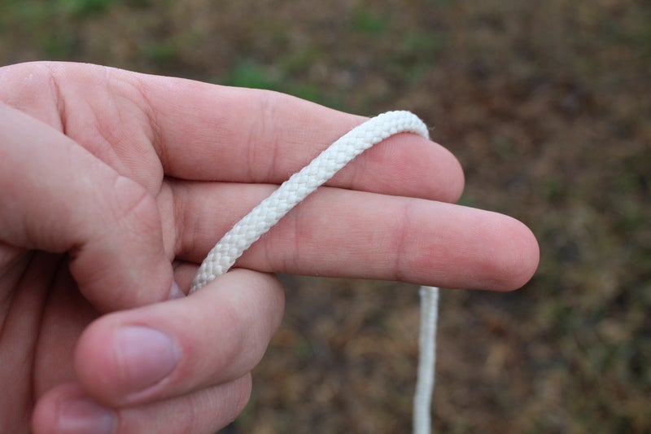

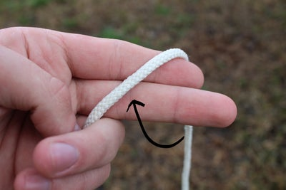

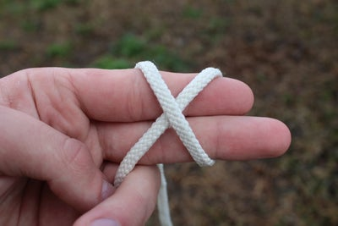

Wrap the rope around your fingers " around the index and the middle finger" and form an X-shape by wrap on the other as shown above.

Make sure to hold the other end of the rope.

## **Step 3: Form Two Parallel Segments**

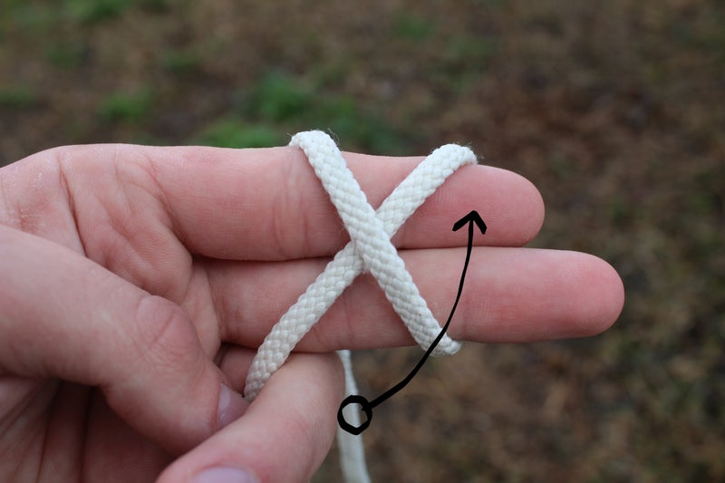

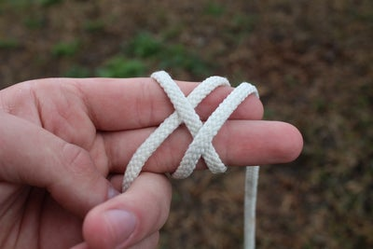

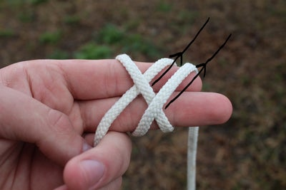

Now rotate the free end of the rope and make it parallel to the right segment of X.

## **Step 4: Grab It From Underneath**

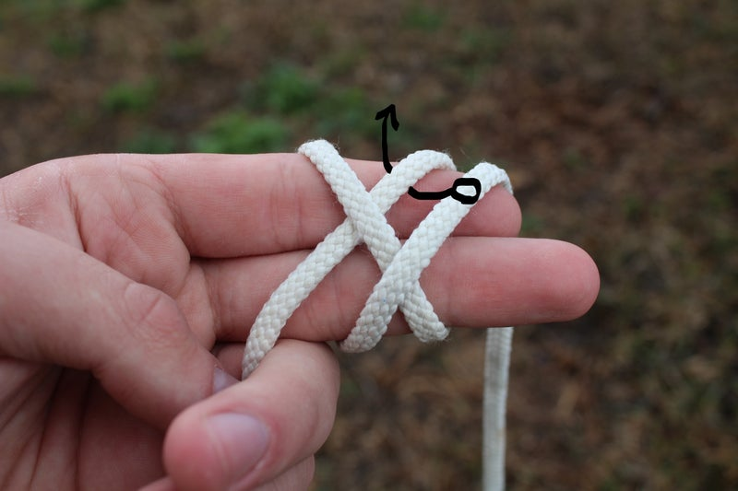

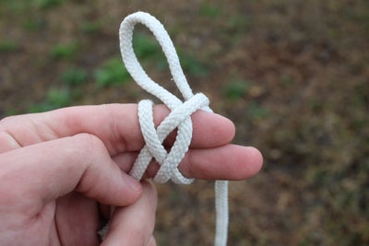

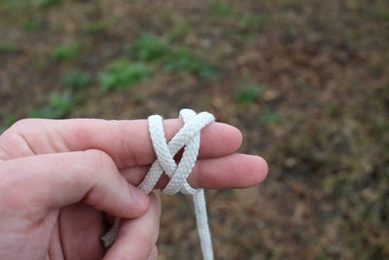

Continue with the long end of the rope by grabbing it from underneath the right segment of the X- shape.

## **Step 5: Switch Over**

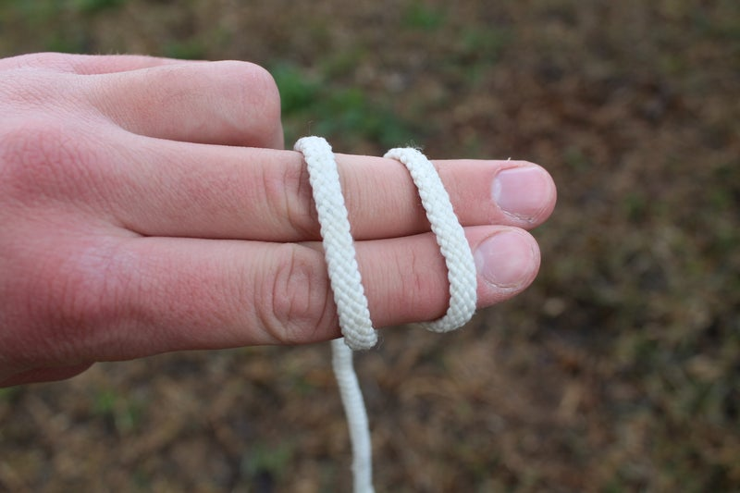

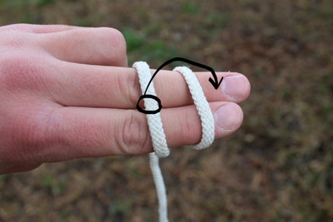

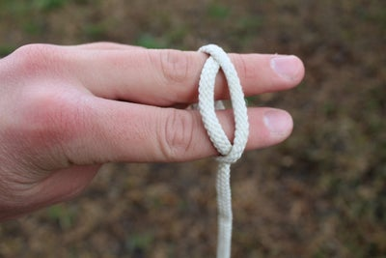

Flip to the other side, now you see two parallel segments, grab the left one and switch from above the right segment and make a braid.

## **Step 6: Start Again From the Back Side**

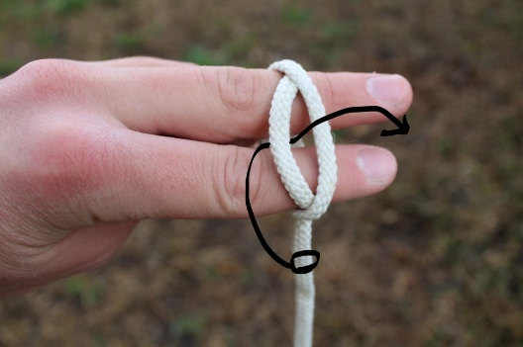

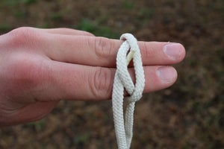

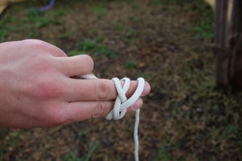

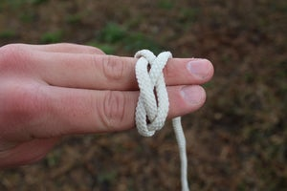

Now grab the free end and pass it through the hole from underneath the left segment.

## **Step 7: Grab It From Underneath Again**

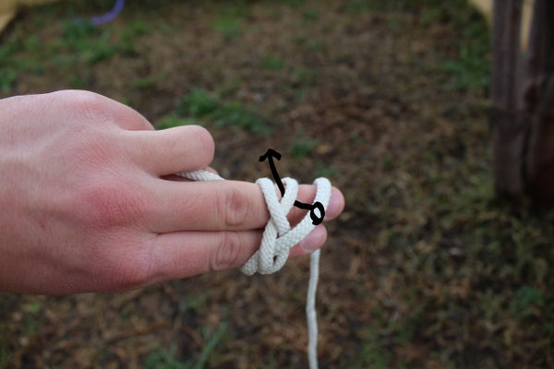

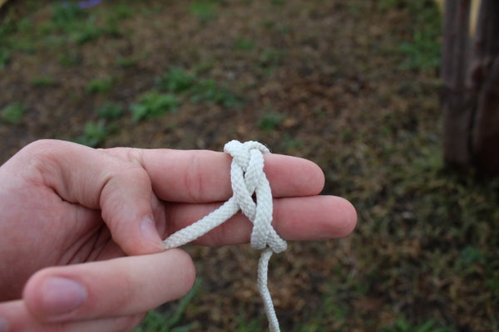

This is the last step of the hard part, after that everything goes well. In this step, you should again take it underneath the segment but now underneath the right one as shown above.

## **Step 8: Double the Rope**

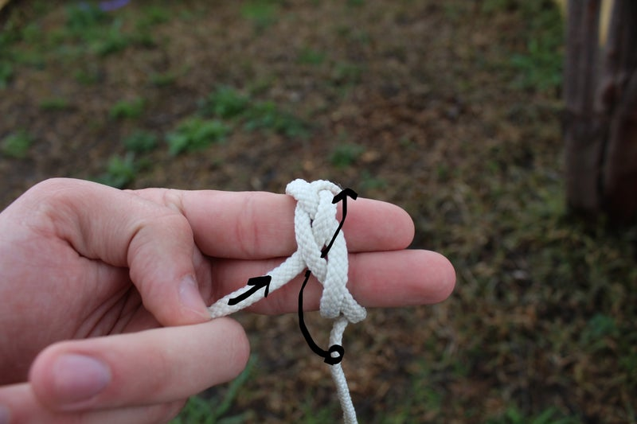

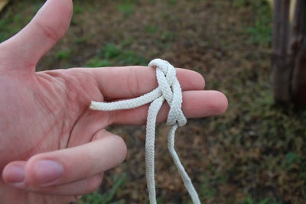

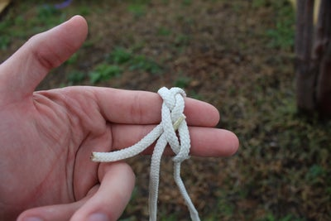

Now, this step is pretty easy where you should start from where you begin. As shown above, the short end is the start line where you should continue by following the rope around a second time to form the woggle.

## **Step 9: Follow the First Line**

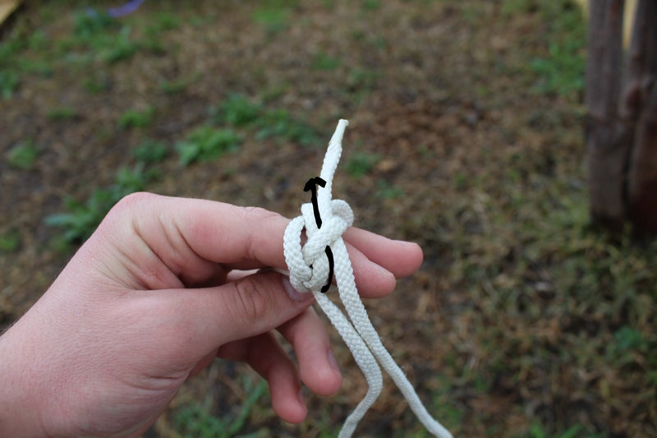

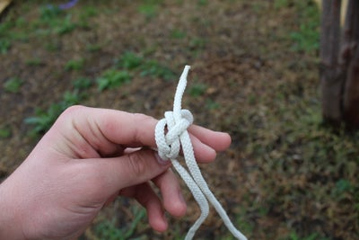

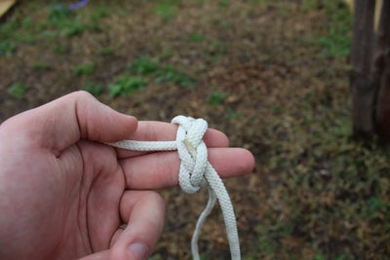

3 More Images

Follow the single line and double it, keep braiding the woggle to got the recommended shape. Here in this step, the thickness of the rope will affect on the diameter of the woggle where it will be bigger with thicker rope.

## **Step 10: Finish It**

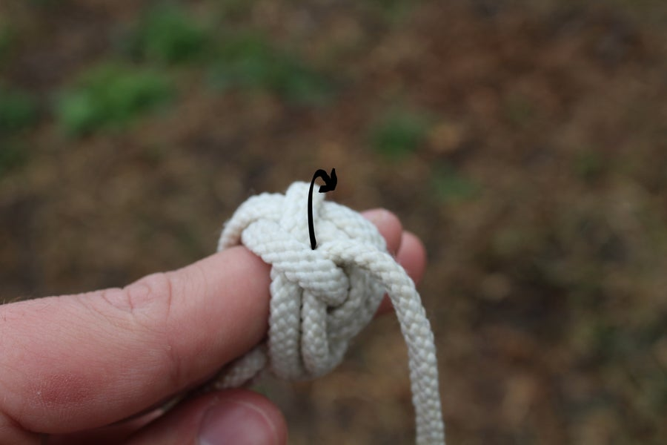

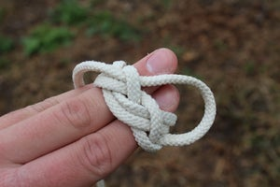

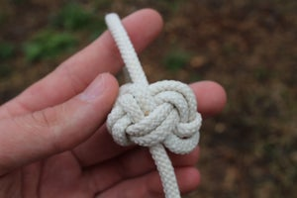

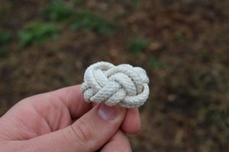

Keep doubling it until all the lines become doubled and no single lines are left. At this point, both ends of the rope will meet and this will be fixed in the next step easily.

## **Step 11: Cut and Join**

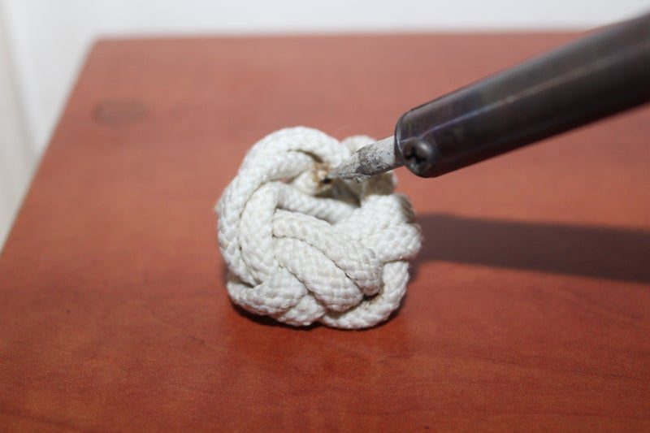

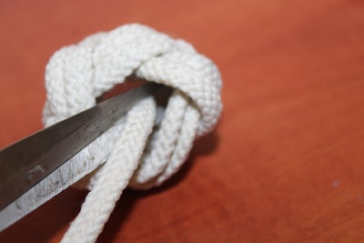

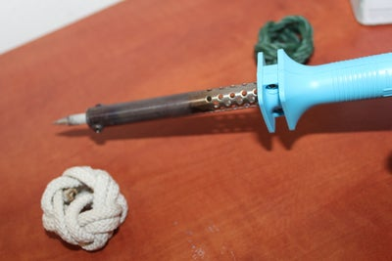

After the two ends meet, you have to cut the two ends to become unseen from the inside of the woggle, then join them using heat. Here I used an iron to join them together.

## **Step 12: The Woggle Is Ready to Use!**

